Save money and be warmer -

Bleed your radiators

Bleeding your radiators is how you get rid of the air pockets that stop hot water circulating around your [central heating system](https://www.eonenergy.com/boilers/central-heating-system.html) efficiently. This puts more strain on your boiler and costs you more money.

If your radiators aren't heating up properly or are cold at the top and warm at the bottom, they could need bleeding. This will allow hot water to circulate through your heating system once again.

It’s a good idea to check this once a year – now is a good time

Bleeding your radiators is easy to do and only takes a few seconds, so your home will soon be warm again.

**What tools do I need to bleed a radiator?**

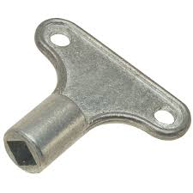

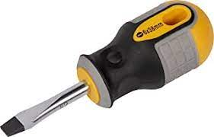

* A radiator bleed key, which can be bought from any hardware shop for under £2 – or a flathead screwdriver.
* An old cloth or a jug to catch any escaping water.

**How to Bleed your Radiator:**

If you're bleeding more than one radiator, start with the one furthest away from your boiler. If you’re living in a two or more storey house, start with the downstairs radiators before repeating upstairs.

1. Make sure your heating is off and the radiators are cold.
2. Find the valve. It is at the top of the radiator and can be at either end. It's round and has a square section in the middle with two notches. Newer radiators may just have a screw head. This is where you put the bleed key (or screwdriver) to let the trapped air escape.
3. Hold an old cloth, or a jug, under the bleed valve, and insert the radiator key. Newer radiators may just need a screwdriver which you insert into the screw.
4. Turn anti-clockwise until air starts escaping (you'll hear a hissing noise).
5. When water starts to escape, turn the key clockwise to re-tighten the valve.
6. Repeat on other radiators that need attention, making your way back towards the boiler
7. Turn your heating back on and check if your radiators are now heating up correctly.

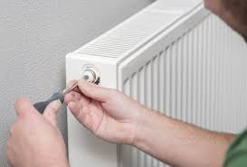

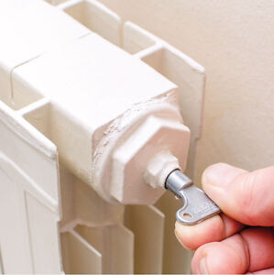

**Check your boiler pressure**

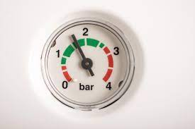

Bleeding radiators can lower your [boiler](https://www.eoninstall.com/boilers/get-a-quote.html) pressure, so it’s a good idea to check if your central heating system need to be re-pressurised at the boiler.

Your boiler pressure should be between 1.0 to 1.5 bars. If it's less than this, you'll need to top up the pressure. If you’re not sure how to do this, contact the office.

**If it’s not working**

If bleeding your radiators doesn’t fix your heating problems, your radiators may need to be drained and flushed. Report as a repair.

If you're having to bleed your radiators more often than once a year you should report this as a repair.

**Watch a Video online**

https://www.youtube.com/watch?v=OL4ot-MNYfE

